Supplementary materials

Additional details of model structure
Aβ is produced in brain ISF and peripheral tissue compartments through cleavage of amyloid precursor protein (APP). APP is first cleaved by BACE to form C-terminal fragment β (CTFβ). Subsequently, CTFβ is cleaved by γ-secretase to form an Aβ monomer. APP, BACE and γ-secretase are synthesized in the brain ISF and peripheral tissue. All species have first order clearance in brain ISF, circulation and peripheral compartments. Proteins are assumed to be transported in and out of the CSF, but there is no endogenous clearance mechanism within this compartment. Soluble BACE can transport between compartments similar to other soluble proteins. Soluble BACE has no downstream pharmacological effect in our model.

All drugs can transport between different compartments following the same transport routes as soluble proteins, but with different transport rates. All drugs undergo first-order elimination in the vascular circulation compartment. IV administration was modeled by introducing the drug directly into circulation. For oral administration, a first-order absorption process is described for the drug to reach the circulation compartment. Since the compartment volume is fixed to a physiological volume, and the bioavailability for small molecule drugs is not known, a dose scaling factor was used to represent a combination of bioavailability and volume of distribution. The value was fitted so that drug concentrations in the plasma compartment in the model match the reported PK data.

The effect of elenbecestat and verubecestat is incorporated in the model as a competitive reversible substrate competing with APP for binding to BACE. The model assumes that BACE inhibitors bind to membrane-bound or soluble BACE with equal potency. An additional peripheral compartment was included for both compounds to describe the slow terminal phase of their PK profiles. No other reactions occur in this second peripheral compartment. Semagacestat, a γ-secretase inhibitor, is incorporated in the model as a reversible substrate competing with CTF-β for binding with γ-secretase.

Data processing
The model focused on fitting fold change from baseline for model parameter calibration due to variation in baseline Aβ levels among trials. Baseline plasma and CSF Aβ concentrations were set to 0.066 nM (Roberts, Elbert, Kasten, Patterson, Sigurdson, Connors, Ovod, Munsell, Mawuenyega, Miller-Thomas, & Others, 2014) and 2.8 nM (Mawuenyega et al., 2010; Roberts, Elbert, Kasten, Patterson, Sigurdson, Connors, Ovod, Munsell, Mawuenyega, Miller-Thomas, & Others, 2014), which is within the range of other reported values (data not shown). Standardized uptake value ratio (SUVR) score is a common approach to report PET imaging results to allow longitudinal comparison as well as comparison across patients. To make standardized uptake value ratio (SUVR) scores from different trials and different tracers comparable, reported quantitative cutoff points for positive plaque were first subtracted from SUVR scores, then, a percentage change from baseline was calculated using Eqn. 1a:

$∆\%SUVR= \frac{{SUVR]}_{t=0}-{SUVR]}_{t=x}}{{SUVR]}_{t=0}-cutoff}×100$ Eqn. 1a

The PET tracer used for different drugs and their cutoff values used in data normalization are listed in the table below:

Drug | PET Tracer | Cutoff SUVR | Reference
Aducanumab | Florbetapir | 1.10 | (Sevigny et al., 2016)
Bapineuzumab | ¹¹C-PiB | 1.35 | (E. Liu et al., 2015)
Crenezumab | Florbetapir | 1.10 | (Salloway et al., 2018)
Solanezumab | Florbetapir | 1.10 | (Honig et al., 2018)
Elenbecestat | Florbetapir | 1.10 | (Lynch et al., 2018)
Verubecestat | ¹⁸F-Flutemetamol | 0.69 | (Egan et al., 2018)

Similarly, a percentage change from baseline for plaque was calculated as:

$∆\%Plaque= \frac{{Plaque]}_{t=0}-{Plaque]}_{t=x}}{{Plaque]}_{t=0}} ×100$ Eqn. 1b

Percentage change from baseline for plaque in simulations was compared to the percentage change from baseline for SUVR data when reported (for aducanumab), or to the reported mean treatment effect size (difference in ΔSUVR between placebo and treatment at any given time for all other drugs).

Clinical trial data showed that inhibition of plasma Aβ by verubecestat was saturated at ~66% (Kennedy et al., 2016). However, this was likely an artifact due to assay background. Therefore, the data was normalized assuming 66% reduction in data equal to 100% Aβ reduction.

Model simulations
Mass action reactions of zeroth, first, or second order were used in the model, assuming that each compartment is well mixed. The list of all the reactions are provided in the supplementary material -- AbetaModel reactions. The model was implemented using KroneckerBio version 0.5.2.3. KroneckerBio is an open source software and it can be downloaded at https://github.com/kroneckerbio. Simulations were performed using MATLAB version 2019a (MathWorks, Natick, MA).

The stable isotope labeling kinetics (SILK) experiments of Aβ (Mawuenyega et al., 2010) were conducted by IV infusion of ¹³C₆ leucine at a constant rate. Increase in labeled Aβ in CSF indicates synthesis of Aβ and transport from ISF to CSF. Following termination of the infusion, the labeled Aβ declined through transport out of CSF into the circulation. To simulate the SILK experiment, Aβ concentrations in all the compartments were set to zero at the beginning of the simulation, then Aβ synthesis in the brain ISF and the peripheral compartments were kept on for 16 hours and simulation was run for a total of 40 hours. Total Aβ (monomer + oligomer) in the CSF was normalized to the maximum value for both simulation and data to allow comparison. Model parameters were adjusted to match the data.

To simulate drug treatment, the model was first run for 67 years with no drug added, so that all species except Aβ plaque were at steady state. At the end of this simulation period, Aβ plaque almost reached steady state and continued to increase very slowly at a rate of <1% per year. Since the model simulates a patient with mild-moderate AD, plaque formation is assumed to be close to steady state at the start of dosing. Drug was added at the indicated dose and dosing regimen. The time point of drug administration was considered time = 0. A body weight of 70 kg was assumed for all the simulations.

Model calibration and analysis

Model calibration was performed through an iterative process. Some rate constants in the model were fixed to literature derived values. Parameters that were not available from literature were adjusted to fit to the data described in the manuscript. Model parameters related to Aβ biology (e.g. rates of production for Aβ species, Aβ aggregation rates, and their transport across compartments) were first calibrated to data from SILK studies for both patients with mild-moderate AD and healthy volunteers (Mawuenyega et al., 2010), as well as to obtain desired steady state concentrations of Aβ monomer, oligomer in plasma, CSF and brain ISF. Drug related parameters were fit to available PK and PD data. The model assumed PK parameters to remain the same for different populations and clinical trials. For the evaluation of the PD effect of therapy on Aβ species, only the pharmacology related parameters (e.g. drug binding K_{d}, ADCP rate) were adjusted. The K_{d} values for mAbs binding to different Aβ species are difficult to measure and can depend on the specific experimental conditions used (e.g. Aβ peptide sequence, the process for forming aggregates). Therefore, we allowed K_{d} values to vary from published values to capture dose-dependent PD changes. The parameters related to Aβ biology were kept the same if possible, during the fitting of PD data. If Aβ biology parameters need to be changed during fitting PD data of one drug, all the previous data used for model calibration are compared again to ensure the model still fits to previous data. At the end of the complete model calibration, it was ensured that one set of Aβ biology model parameters was applied to all 7 drugs, and that drug-specific parameters such as drug affinity for Aβ species and elimination rate could account for differences in drug response in various clinical trials. This approach was chosen to allow the fully calibrated model to serve as a platform model for the simulation of various therapies on an identical biology background. Various model simulations were performed with this final model. Changes in specific parameter(s) from the nominal values are described for each simulation.

Figure S1: Model fitting to the SILK data.

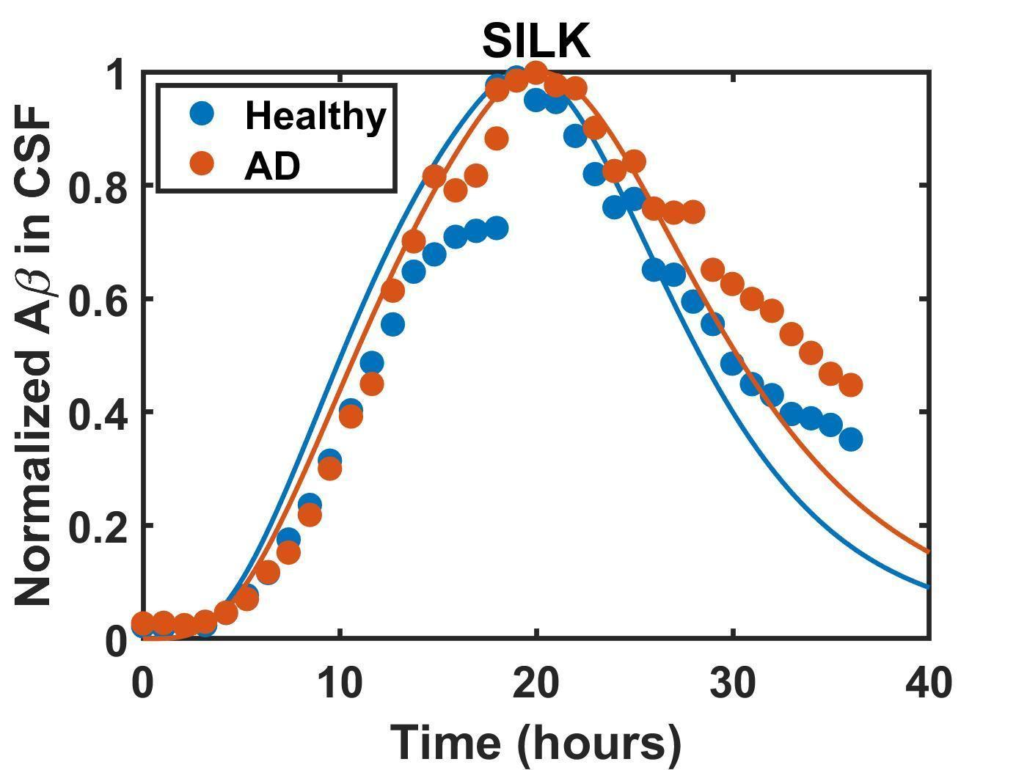

Figure S2: Model predicted free monomer and oligomer levels for Q4W IV Solanezumab treatment

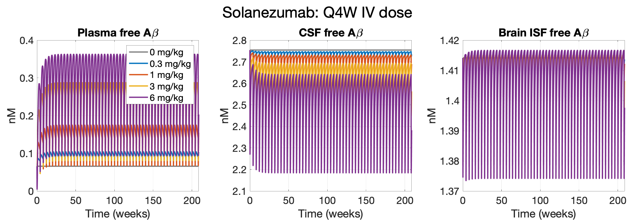

Figure S3: Model predicted free monomer and oligomer levels in ISF with daily oral elenbecestat treatment

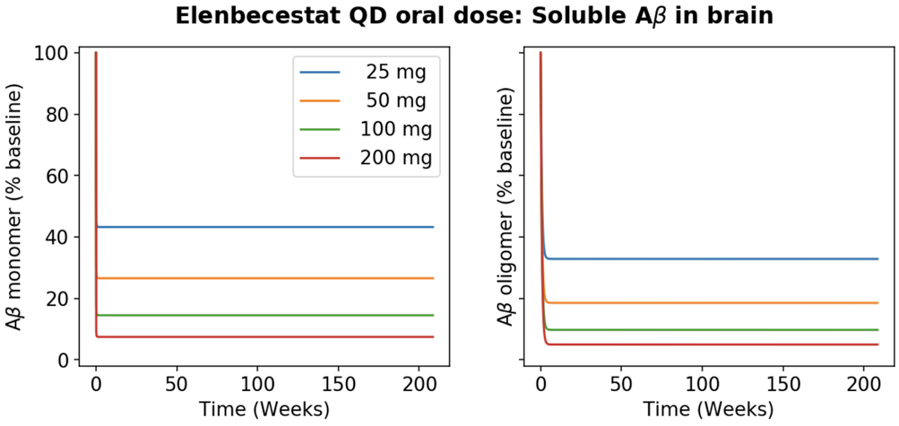

Figure S4: Model predicted free monomer and oligomer levels in ISF with daily oral verubecestat treatment

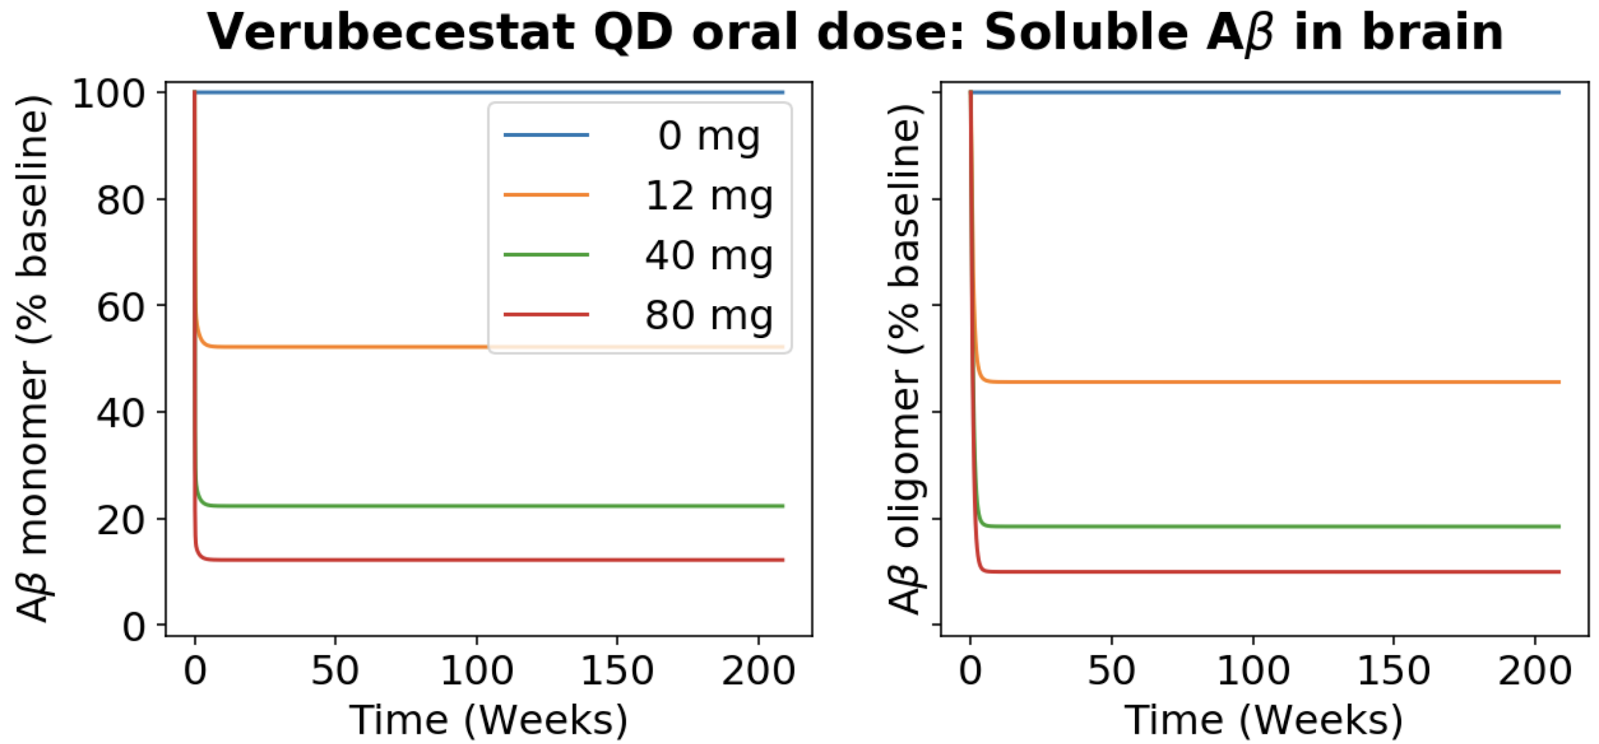

Supplementary tables

Table S1. Summary of clinical trial data of the 7 drugs used for the model development

Drug | Data type | Study and Dose | Patient population | Reference
Aducanumab | PK | Phase 1: 0.3-60 mg/kg, single dose IV | Mild to moderate AD | (Ferrero et al., 2016)
Aducanumab | Plasma total Aβ | Phase 1: 0.3-60 mg/kg, single dose IV | Mild to moderate AD | (Ferrero et al., 2016)
Aducanumab | Amyloid Plaque | Phase 1b: 1-10mg/kg IV repeat dose (Q4W) | Prodromal or mild AD | (Sevigny et al., 2016) & (Biogen news release)
Crenezumab | PK | Phase 1: 0.3, 1, 3, 10 mg/kg single dose IV | Mild to moderate AD | (Adolfsson et al., 2012)
Crenezumab | Plasma total Aβ | Phase 2:15 mg/kg IV repeat dose (Q4W) | Mild to moderate AD | (Salloway et al., 2018)
Crenezumab | Amyloid Plaque | Phase 2:15 mg/kg IV repeat dose (Q4W) | Mild to moderate AD | (Salloway et al., 2018)
Solanezumab | PK | Phase 1: 0.5, 1.5, 4, 10 mg/kg single dose IV | Mild to moderate AD | (Uenaka et al., 2012)
Solanezumab | Plasma total Aβ | Phase 1: 0.5, 1.5, 4, 10 mg/kg single dose IV | Mild to moderate AD | (Uenaka et al., 2012)
Solanezumab | CSF total Aβ | Phase 2: 100, 400 mg IV repeat dose (Q4W) | Mild to moderate AD | (Farlow et al., 2012)
Solanezumab | Amyloid Plaque | Phase 3: 400 mg IV repeat dose (Q4W) | Mild AD | (Honig et al., 2018)
Bapineuzumab | PK | Phase 1: 0.5, 1.5, 5 mg/kg single dose IV | Mild to moderate AD | (Black et al., 2010)
Bapineuzumab | Plasma total Aβ | Phase 3: 0.5, 1 mg/kg IV repeat dose (Q13W) | Mild to moderate AD | (Vandenberghe et al., 2016)
Bapineuzumab | Amyloid Plaque | Phase 3: 0.5, 1 mg/kg IV repeat dose (Q13W) | Mild to moderate AD, (ApoE carrier and non-carrier pooled) | (E. Liu et al., 2015)
Elenbecestat | PK | Phase 1: 5, 10, 25, 50, 100, 200, 400, 800 mg single oral dose | Healthy individuals | (Lai et al., 2012)
Elenbecestat | Plasma total Aβ | Phase 1: 25, 50, 100, 200 mg daily oral dose for 14 days | Healthy individuals | (Albala et al., 2012)
Elenbecestat | CSF total Aβ | Phase 1: 25, 50, 100, 200 mg daily oral dose for 14 days | Healthy individuals | (Albala et al., 2012)
Elenbecestat | Amyloid Plaque | Phase 2: 50 mg daily oral dose for 18 month | Mild to moderate AD | (Lynch et al., 2018)
Verubecestat | PK: Plasma | Phase 1: 20, 100, 450 mg single oral dose | Healthy individuals | (Chris Min et al., 2019)
Verubecestat | Plasma total Aβ | Phase 2: 10, 40, 150, 250 daily oral dose for 14 days | Healthy & moderate AD | (Kennedy et al., 2016)
Verubecestat | CSF total Aβ | Phase 2: 10, 40, 150, 250 daily oral dose for 14 days | Healthy & moderate AD | (Kennedy et al., 2016)
Verubecestat | Amyloid Plaque | Phase 3: 12, 40 mg once daily oral dose for 78 weeks | moderate AD | (Egan et al., 2018)
Semagacestat | PK: CSF | Phase 1:100, 140, 280 mg single oral dose | Healthy individuals | (Bateman et al., 2009)
Semagacestat | Plasma total Aβ | Phase 1: 60, 100, 140 mg single oral dose | Healthy individuals | (Siemers et al., 2007)
Semagacestat | Amyloid Plaque | Phase 3: 100, 140 mg repeat dose (daily for 76 weeks) | Mild to moderate AD | (Doody et al., 2013)  No change reported, so data not plotted

Table S2. Steady state concentrations of Aβ species in different compartments based on model simulations

Aβ | Monomer | Oligomer | Plaque
Plasma (nM) | 6.6 * 10⁻² | 6.9* 10⁻¹² | 0
CSF (nM) | 2.8 | 2.0 * 10⁻² | 0
Brain (nM) | 0.75 | 4.4 | 39

Table S3. Model parameter description and values

Parameter description | Symbol | Value | Reference
Volume of plasma | Vplasma | 3 L | (Pearson et al., 2008)
Volume of peripheral | Vperipheral | 3 L | Assumed to be same as plasma
Volume of csf | Vcsf | 0.139 L | (Nau et al., 2010)
Volume of brain ISF | Vbisf | 0.261 L | (Shah & Betts, 2012)
Association rate of APP and BACE binding | konPP | 1E-3 /(nM*s) | (Schlosshauer & Baker, 2004)
Turnover number for BACE | kcatBACE | 7.2E-3 /s | (Ahmed et al., 2010)
Turnover number for $γ$ secretase activity | kcatGamma | 1.2E-3 /s | (Kamp et al., 2015)
Rate constant for sBACE formation from BACE | kcleave | 2E-7 /s | Fitted
Rate constant for monomer aggregation to form oligomer | kM2G | 1.4E-5 /s | Fitted
Rate constant of oligomer dissociation to monomer in plasma | kG2M_ plasma | 1.4E5 /s | Fitted
Rate constant of oligomer dissociation to monomer in peripheral | kG2M_per | 1.4E5 /s | Fitted
Rate constant of oligomer dissociation to monomer in csf | kG2M_csf | 2.8E-3 /s | Fitted
Rate constant of oligomer dissociation to monomer in brain ISF | kG2M_bisf | 1.4E-8 /s | Fitted
Oligomer to plaque formation rate constant | kG2P | 7.0E-8 /s | Fitted
Plaque to oligomer dissociation rate constant | kP2G_bisf | 7E-11 /s | Assumed to be 1000x slower than the association rate constant
APP degradation rate constant in peripheral, and brain ISF | kclearAPP | 6.93E-5 /s | (Ring et al., 2007)
APP synthesis rate constant in peripheral | ksynthAPP_ per | 7.28E-2 nmol/s | Fitted
APP synthesis rate constant in brain ISF | ksynthAPP_ bisf | 2E-3 nmol /s | Fitted
BACE degradation rate constant in peripheral and brain ISF | kclearBACE | 1.2E-5 /s | (Huse et al. 2000)
BACE synthesis rate constant in peripheral | ksynthBACE_per | 9.0E-4 nmol/s | Fitted
BACE synthesis rate constant in brain ISF | ksynthBACE_bisf | 1.0E-4 nmol/s | Fitted
$γ$ secretase degradation rate constant in peripheral and brain ISF | kclearGamma | 8.0E-6 /s | (Dries & Yu, 2008)
$γ$ secretase synthesis rate constant in peripheral. | ksynthGamma_per | 6.0E-4 nmol/s | Fitted
$γ$ secretase synthesis rate constant in brain ISF. | ksynthGamma_bisf | 5.2E-5 nmol/s | Fitted
FcR synthesis rate constant in brain ISF | ksynthFcR_ bisf | 2.5E-5 nmol/s | Fitted
A$β$ monomer clearance rate constant in plasma. | kclearAbeta_ plasma | 1.9E-4 /s | (Ovod et al., 2017)
A$β$ oligomer clearance rate constant in plasma. | kclearAolig_ plasma | 1.9E-4 /s | Assumed same as monomer
A$β$ monomer clearance rate constant in brain ISF. | kclearAbeta_ bisf | 5.5E-5 /s | (Cirrito et al., 2003)
A$β$ oligomer clearance rate constant in brain ISF. | kclearAolig_ bisf | 2.2E-8 /s | Fitted
A$β$ plaque clearance rate in brain ISF. | kclearAplaq | 8.0E-9 /s | Fitted
Dissociation rate of APP and BACE binding | koffBACE | 120 /s | (Baranello et al., 2015; Lin et al., 2000)
Dissociation rate of CTF$β$ and $γ$-secretase binding | koffGamma | 0.4 /s | (Chávez-Gutiérrez et al., 2012)
FcR degradation rate constant in brain ISF | kclearFcR | 9.6E-5 /s | (Mellman et al., 1983)
Transport rate constant of A$β$ monomer from plasma to peripheral | k12Abeta | 3E-4 /s | Fitted
Transport rate constant of A$β$ oligomer from plasma to peripheral | k12Aoli | 3E-4 /s | Assume to be the same as A$β$ monomer
Transport rate constant of sBACE from plasma to peripheral | k12BACE | 3E-4 /s | Assume to be the same as A$β$ monomer
Transport rate constant of A$β$ monomer from plasma to CSF | k13Abeta | 1.72E-9 /s | Assume to be the same as mAb  Healthy subjects has a rate of 1.4x of this nominal value
Transport rate constant of A$β$ oligomer from plasma to CSF | k13Aoli | 1.72E-9 /s | Assume to be the same as mAb
Transport rate constant of sBACE from plasma to CSF | k13BACE | 1.72E-9 /s | Assume to be the same as mAb
Transport rate constant of A$β$ monomer from plasma to brain ISF | k14Abeta | 1.48E-7 /s | Fitted
Transport rate constant of A$β$ oligomer from plasma to brain ISF | k14Aoli | 1.48E-7 /s | Assume to be the same as A$β$ monomer
Transport rate constant of sBACE from plasma to brain ISF | k14BACE | 2.0E-8 /s | Fitted
Transport rate constant of A$β$ monomer from peripheral to plasma | k21Abeta | 2.0E-5 /s | Fitted
Transport rate constant of A$β$oligomer from peripheral to plasma | k21Aoli | 2.0E-5 /s | Assume to be the same as A$β$ monomer
Transport rate constant of sBACE from peripheral to plasma | k21BACE | 2.0E-5 /s | Fitted
Transport rate constant of A$β$ monomer from CSF to plasma | k31Abeta | 4.5E-5 /s | Fitted
Transport rate constant of A$β$ oligomer from CSF to plasma | k31Aoli | 4.5E-5 /s | Assume to be the same as A$β$ monomer
Transport rate constant of sBACE from CSF to plasma | k31BACE | 4.5E-5 /s | Assume to be the same as A$β$ monomer
Transport rate constant of A$β$ monomer from brain ISF to plasma | k41Abeta | 1.48E-8 /s | Fitted
Transport rate constant of A$β$ oligomer from brain ISF to plasma | k41Aoli | 1.48E-8 /s | Assume to be the same as A$β$ monomer
Transport rate constant of sBACE from brain ISF to plasma | k41BACE | 8.0E-5 /s | Fit to sBACE level from (Bernier et al., 2013)
Transport rate constant of A$β$ monomer from brain ISF to CSF | k43Abeta | 7.5E-5 /s | Fit to SILK data: (Mawuenyega et al., 2010)
Transport rate constant of A$β$ oligomer from brain ISF to CSF | k43Aoli | 2.25E-6 /s | Fitted
Transport rate constant of sBACE from brain ISF to CSF | k43BACE | 1.5E-5 /s | Fitted

Table S4. mAb-specific model parameters

Parameter | Symbol | Units | Aduc | Bapi | Cren | Sola
mAb molecular weight | MW_mAb | g/mol | 150000 | 148800 | 148800 | 148800
mAb clearance rate constant | kclearmAb | 1/s | 1.5E-7 | 8.4E-7 | 1.0E-6 | 8.9E-7
mAb:Aβ monomer complex clearance rate constant | kclearAbAb | 1/s | 1.5E-7 | 8.4E-7 | 1.0E-6 | 8.9E-7
mAb:Aβ oligomer complex clearance rate constant | kclearmAbAoli | 1/s | 1.5E-7 | 8.4E-7 | 1.0E-6 | 8.9E-7
FcR degradation rate constant in brain ISF | kclearFcR | 1/s | 9.6E-5
Fc receptor concentration | cFcR_bisf | nM | 1
Fc:Fc𝛾R1 binding on rate constant | konPF | 1/(nM⋅s) | 0.001
Fc:Fc𝛾R1 affinity | KdPF | nM | 15.6 | 15.6 | 62.4 | 15.6
Turnover rate constant for ADCP | kclearADCP | 1/s | 3.7E-5 | 3.7E-5 | 1.2E-5 | 3.7E-5
mAb:plaque binding on rate constant | konPD | 1/(nM⋅s) | 0.001 |  |  | 0
mAb:Aβ binding on rate constant | konAb | 1/(nM⋅s) | 0.001
mAb:Aβ monomer affinity | Kdma0 | nM | 8000 | 4 | 24 | 1.8
mAb:Aβ oligomer affinity | Kdma1 | nM | 4 | 1.5 | 6 | 4
mAb:plaque affinity | Kdma2 | nM | 4 | 1.5 | 6 | NA
mAb plasma to peripheral transport rate constant | k12mAb | 1/s | 2.00E-6
mAb:Aβ monomer plasma to peripheral transport rate constant | k12mono | 1/s | 2.00E-6
mAb:Aβ oligomer plasma to peripheral transport rate constant | k12mix | 1/s | 2.00E-6
mAb peripheral to plasma transport rate constant | k21mAb | 1/s | 1.00E-06 | 1.50E-06 | 1.50E-06 | 1.50E-06
mAb:Aβ monomer peripheral to plasma transport rate constant | k21mono | 1/s | 1.00E-06 | 1.50E-06 | 1.50E-06 | 1.50E-06
mAb:Aβ oligomer peripheral to plasma rate constant | k21mix | 1/s | 1.00E-06 | 1.50E-06 | 1.50E-06 | 1.50E-06
mAb plasma to CSF transport rate constant | k13mAb | 1/s | 1.72E-09
mAb:Aβ monomer plasma to CSF transport rate constant | k13mono | 1/s | 1.72E-09
mAb:Aβ oligomer plasma to CSF transport rate constant | k13mix | 1/s | 1.72E-09
mAb CSF to plasma transport rate constant | k31mAb | 1/s | 8.00E-06
mAb:Aβ monomer CSF to plasma transport rate constant | k31mono | 1/s | 8.00E-06
mAb:Aβ oligomer CSF to plasma rate constant | k31mix | 1/s | 8.00E-06
mAb plasma to brain ISF transport rate constant | k14mAb | 1/s | 1.72E-09
mAb:Aβ monomer plasma to brain ISF transport rate constant | k14mono | 1/s | 1.72E-09
mAb:Aβ oligomer plasma to brain ISF transport rate constant | k14mix | 1/s | 1.72E-09
mAb brain ISF to plasma transport rate constant | k41mAb | 1/s | 8.10E-06
mAb:Aβ monomer brain ISF to plasma transport rate constant | k41mono | 1/s | 8.10E-06
mAb:Aβ oligomer brain ISF to plasma rate constant | k41mix | 1/s | 1.48E-08
mAb brain ISF to CSF transport rate constant | k43mAb | 1/s | 3.20E-06
mAb:Aβ monomer brain ISF to CSF transport rate constant | k43mono | 1/s | 2.33E-08
mAb:Aβ oligomer brain ISF to CSF rate constant | k43mix | 1/s | 2.33E-08

Table S5. Small molecule drug specific model parameters used in model simulations

Parameter | Symbol (Drug = BI or GI) | Units | Elenbecestat | Verubecestat | Semagacestat
Drug molecular weight | MW_Drug | g/mol | 437.4 | 409.4 | 361.4
Oral scaling factor | Drug_sf |  | 0.01 | 0.02 | 0.04
Drug absorption rate constant | kabsDrug | 1/s | 1.50E-4 | 1.50E-4 | 2.00E-4
Drug elimination rate constant | kclearDrug | s | 2.5E-4 | 8.3E-5 | 1.0E-3
Drug:Target binding affinity | KiDrug | nM | 2 | 7.8 | 15
Drug plasma to peripheral transport rate constant | k12Drug | 1/s | 3.00E-3 | 5.2E-4 | 1.40E-03
Drug peripheral to plasma transport rate constant | k21Drug | 1/s | 2.00E-3 | 1.73E-4 | 1.40E-03
Free to plasma protein-bound drug transition rate constant | k1NDrug | 1/s | 840 | 650 | 647
Plasma protein-bound to free drug transition rate constant | kN1Drug | 1/s | 320 | 532 | 510
Plasma to CSF drug transport rate constant | k13drug | 1/s | 1.72E-09 | 1.72E-09 | 1.72E-09
CSF to plasma drug transport rate constant | k31Drug | 1/s | 7.00E-05 | 5.00E-04 | 6.00E-05
Plasma to brain ISF drug transport rate constant | k14Drug | 1/s | 1.50E-5 | 1.80E-5 | 5.92E-4
Brain ISF to plasma drug transport rate constant | k41Drug | 1/s | 3.00E-4 | 6.3E-4 | 6.00E-3
Plasma to 2nd peripheral compartment drug transport rate constant | k15Drug | 1/s | 2.48E-05 | 1.25E-05 | NA
2nd peripheral compartment to plasma drug transport rate constant | k51Drug | 1/s | 9.90E-06 | 1.39E-06 | NA
Free to protein-bound drug transition rate constant in brain | k4NDrug | 1/s | 840 | 650 | 647
Protein-bound to free drug transition rate constant in brain | kN4Drug | 1/s | 320 | 532 | 510
Brain ISF to CSF drug transport rate constant | k43Drug | 1/s | 4.00E-5 | 6.00E-5 | 6.00E-5

References
Adolfsson, O., Pihlgren, M., Toni, N., Varisco, Y., Buccarello, A. L., Antoniello, K., Lohmann, S., Piorkowska, K., Gafner, V., Atwal, J. K., Maloney, J., Chen, M., Gogineni, A., Weimer, R. M., Mortensen, D. L., Friesenhahn, M., Ho, C., Paul, R., Pfeifer, A., … Watts, R. J. (2012). An Effector-Reduced Anti- -Amyloid (A ) Antibody with Unique A Binding Properties Promotes Neuroprotection and Glial Engulfment of A. In Journal of Neuroscience (Vol. 32, Issue 28, pp. 9677–9689). https://doi.org/10.1523/jneurosci.4742-11.2012
Ahmed, R. R., Holler, C. J., Webb, R. L., Li, F., Beckett, T. L., & Murphy, M. P. (2010). BACE1 and BACE2 enzymatic activities in Alzheimer’s disease. Journal of Neurochemistry, 112(4), 1045–1053.
Albala, B., Kaplow, J. M., Lai, R., Matijevic, M., Aluri, J., & Satlin, A. (2012). CSF amyloid lowering in human volunteers after 14 days’ oral administration of the novel BACE1 inhibitor E2609. Alzheimer’s & Dementia: The Journal of the Alzheimer's Association, 8(4), S743.
Bao, F., Wicklund, L., Lacor, P. N., Klein, W. L., Nordberg, A., & Marutle, A. (2012). Different β-amyloid oligomer assemblies in Alzheimer brains correlate with age of disease onset and impaired cholinergic activity. Neurobiology of Aging, 33(4), 825.e1–e13.
Baranello, R. J., Bharani, K. L., Padmaraju, V., Chopra, N., Lahiri, D. K., Greig, N. H., Pappolla, M. A., & Sambamurti, K. (2015). Amyloid-beta protein clearance and degradation (ABCD) pathways and their role in Alzheimer’s disease. Current Alzheimer Research, 12(1), 32–46.
Bateman, R. J., Siemers, E. R., Mawuenyega, K. G., Wen, G., Browning, K. R., Sigurdson, W. C., Yarasheski, K. E., Friedrich, S. W., DeMattos, R. B., May, P. C., Paul, S. M., & Holtzman, D. M. (2009). A γ-secretase inhibitor decreases amyloid-β production in the central nervous system. In Annals of Neurology (Vol. 66, Issue 1, pp. 48–54). https://doi.org/10.1002/ana.21623
Bernier, F., Sato, Y., Matijevic, M., Desmond, H., McGrath, S., Burns, L., Kaplow, J. M., & Albala, B. (2013). Clinical study of E2609, a novel BACE1 inhibitor, demonstrates target engagement and inhibition of BACE1 activity in CSF. Alzheimer’s & Dementia: The Journal of the Alzheimer's Association, 9(4), P886.
Black, R. S., Sperling, R. A., Safirstein, B., Motter, R. N., Pallay, A., Nichols, A., & Grundman, M. (2010). A Single Ascending Dose Study of Bapineuzumab in Patients With Alzheimer Disease. In Alzheimer Disease & Associated Disorders (Vol. 24, Issue 2, pp. 198–203). https://doi.org/10.1097/wad.0b013e3181c53b00
Chávez-Gutiérrez, L., Bammens, L., Benilova, I., Vandersteen, A., Benurwar, M., Borgers, M., Lismont, S., Zhou, L., Van Cleynenbreugel, S., Esselmann, H., Wiltfang, J., Serneels, L., Karran, E., Gijsen, H., Schymkowitz, J., Rousseau, F., Broersen, K., & De Strooper, B. (2012). The mechanism of γ-Secretase dysfunction in familial Alzheimer disease. The EMBO Journal, 31(10), 2261–2274.
Chris Min, K., Dockendorf, M. F., Palcza, J., Tseng, J., Ma, L., Stone, J. A., Kleijn, H. J., Hodsman, P., Masuo, K., Tanen, M., & Others. (2019). Pharmacokinetics and Pharmacodynamics of the BACE 1 Inhibitor Verubecestat (MK-8931) in Healthy Japanese Adults: A Randomized, Placebo-Controlled Study. Clinical Pharmacology & Therapeutics, 105(5), 1234–1243.
Cirrito, J. R., May, P. C., O’Dell, M. A., Taylor, J. W., Parsadanian, M., Cramer, J. W., Audia, J. E., Nissen, J. S., Bales, K. R., Paul, S. M., DeMattos, R. B., & Holtzman, D. M. (2003). In Vivo Assessment of Brain Interstitial Fluid with Microdialysis Reveals Plaque-Associated Changes in Amyloid-β Metabolism and Half-Life. The Journal of Neuroscience: The Official Journal of the Society for Neuroscience, 23(26), 8844–8853.
Cohen, S. I. A., Vendruscolo, M., Dobson, C. M., & Knowles, T. P. J. (2012). From macroscopic measurements to microscopic mechanisms of protein aggregation. Journal of Molecular Biology, 421(2-3), 160–171.
Cole, S. L., & Vassar, R. (2008). The Role of Amyloid Precursor Protein Processing by BACE1, the β-Secretase, in Alzheimer Disease Pathophysiology. The Journal of Biological Chemistry, 283(44), 29621–29625.
Doody, R. S., Raman, R., Farlow, M., Iwatsubo, T., Vellas, B., Joffe, S., Kieburtz, K., He, F., Sun, X., Thomas, R. G., Aisen, P. S., Alzheimer’s Disease Cooperative Study Steering Committee, Siemers, E., Sethuraman, G., Mohs, R., & Semagacestat Study Group. (2013). A phase 3 trial of semagacestat for treatment of Alzheimer’s disease. The New England Journal of Medicine, 369(4), 341–350.
Dries, D. R., & Yu, G. (2008). Assembly, maturation, and trafficking of the gamma-secretase complex in Alzheimer’s disease. Current Alzheimer Research, 5(2), 132–146.
Egan, M. F., Kost, J., Tariot, P. N., Aisen, P. S., Cummings, J. L., Vellas, B., Sur, C., Mukai, Y., Voss, T., Furtek, C., Mahoney, E., Harper Mozley, L., Vandenberghe, R., Mo, Y., & Michelson, D. (2018). Randomized Trial of Verubecestat for Mild-to-Moderate Alzheimer’s Disease. The New England Journal of Medicine, 378(18), 1691–1703.
Farlow, M., Arnold, S. E., van Dyck, C. H., Aisen, P. S., Snider, B. J., Porsteinsson, A. P., Friedrich, S., Dean, R. A., Gonzales, C., Sethuraman, G., DeMattos, R. B., Mohs, R., Paul, S. M., & Siemers, E. R. (2012). Safety and biomarker effects of solanezumab in patients with Alzheimer’s disease. Alzheimer’s & Dementia: The Journal of the Alzheimer's Association, 8(4), 261–271.
Ferrero, J., Williams, L., Stella, H., Leitermann, K., Mikulskis, A., O’Gorman, J., & Sevigny, J. (2016). First-in-human, double-blind, placebo-controlled, single-dose escalation study of aducanumab (BIIB037) in mild-to-moderate Alzheimer’s disease. Alzheimer’s & Dementia: Translational Research & Clinical Interventions, 2(3), 169–176.
Fleisher, A. S., Raman, R., Siemers, E. R., Becerra, L., Clark, C. M., Dean, R. A., Farlow, M. R., Galvin, J. E., Peskind, E. R., Quinn, J. F., Sherzai, A., Brooke Sowell, B., Aisen, P. S., & Thal, L. J. (2008). Phase 2 Safety Trial Targeting Amyloid β Production With a γ-Secretase Inhibitor in Alzheimer Disease. Archives of Neurology, 65(8), 1031–1038.
Fukumoto, H., Tokuda, T., Kasai, T., Ishigami, N., Hidaka, H., Kondo, M., Allsop, D., & Nakagawa, M. (2010). High-molecular-weight β-amyloid oligomers are elevated in cerebrospinal fluid of Alzheimer patients. In The FASEB Journal (Vol. 24, Issue 8, pp. 2716–2726). https://doi.org/10.1096/fj.09-150359
Fukushima, T., Osada, Y., Ishibashi, A., & Lucas, F. (2012). Novel BACE1 inhibitor, E2609, lowers Aβ levels in the brain, cerebrospinal fluid and plasma in rats and guinea pigs. Alzheimer’s & Dementia: The Journal of the Alzheimer's Association, 8(4), P223–P224.
Haniu, M., Denis, P., Young, Y., Mendiaz, E. A., Fuller, J., Hui, J. O., Bennett, B. D., Kahn, S., Ross, S., Burgess, T., Katta, V., Rogers, G., Vassar, R., & Citron, M. (2000). Characterization of Alzheimer’s β-Secretase Protein BACE: A PEPSIN FAMILY MEMBER WITH UNUSUAL PROPERTIES. The Journal of Biological Chemistry, 275(28), 21099–21106.
Hellström-Lindahl, E., Viitanen, M., & Marutle, A. (2009). Comparison of Abeta levels in the brain of familial and sporadic Alzheimer’s disease. Neurochemistry International, 55(4), 243–252.
Honig, L. S., Vellas, B., Woodward, M., Boada, M., Bullock, R., Borrie, M., Hager, K., Andreasen, N., Scarpini, E., Liu-Seifert, H., Case, M., Dean, R. A., Hake, A., Sundell, K., Poole Hoffmann, V., Carlson, C., Khanna, R., Mintun, M., DeMattos, R., … Siemers, E. (2018). Trial of Solanezumab for Mild Dementia Due to Alzheimer’s Disease. The New England Journal of Medicine, 378(4), 321–330.
Huse, J. T., Pijak, D. S., Leslie, G. J., Lee, V. M.-Y., & Doms, R. W. (2000). Maturation and Endosomal Targeting of β-Site Amyloid Precursor Protein-cleaving Enzyme: THE ALZHEIMER’S DISEASE β-SECRETASE. The Journal of Biological Chemistry, 275(43), 33729–33737.
Kamp, F., Winkler, E., Trambauer, J., Ebke, A., Fluhrer, R., & Steiner, H. (2015). Intramembrane proteolysis of β-amyloid precursor protein by γ-secretase is an unusually slow process. Biophysical Journal, 108(5), 1229–1237.
Kandimalla, K. K., Curran, G. L., Holasek, S. S., Gilles, E. J., Wengenack, T. M., & Poduslo, J. F. (2005). Pharmacokinetic analysis of the blood-brain barrier transport of 125I-amyloid β protein 40 in wild-type and alzheimer’s disease transgenic mice (APP, PS1) and its implications for amyloid plaque formation. The Journal of Pharmacology and Experimental Therapeutics, 313(3), 1370–1378.
Kennedy, M. E., Stamford, A. W., Chen, X., Cox, K., Cumming, J. N., Dockendorf, M. F., Egan, M., Ereshefsky, L., Hodgson, R. A., Hyde, L. A., Jhee, S., Kleijn, H. J., Kuvelkar, R., Li, W., Mattson, B. A., Mei, H., Palcza, J., Scott, J. D., Tanen, M., … Forman, M. S. (2016). The BACE1 inhibitor verubecestat (MK-8931) reduces CNS β-amyloid in animal models and in Alzheimer’s disease patients. Science Translational Medicine, 8(363), 363ra150.
Lai, R., Albala, B., Kaplow, J. M., Aluri, J., Yen, M., & Satlin, A. (2012). First-in-human study of E2609, a novel BACE1 inhibitor, demonstrates prolonged reductions in plasma beta-amyloid levels after single dosing. Alzheimer’s & Dementia: The Journal of the Alzheimer's Association, 8(4), P96.
Lin, X., Koelsch, G., Wu, S., Downs, D., Dashti, A., & Tang, J. (2000). Human aspartic protease memapsin 2 cleaves the β-secretase site of β-amyloid precursor protein. Proceedings of the National Academy of Sciences of the United States of America, 97(4), 1456–1460.
Liu, E., Schmidt, M. E., Margolin, R., Sperling, R., Koeppe, R., Mason, N. S., Klunk, W. E., Mathis, C. A., Salloway, S., Fox, N. C., Hill, D. L., Les, A. S., Collins, P., Gregg, K. M., Di, J., Lu, Y., Tudor, I. C., Wyman, B. T., Booth, K., … Bapineuzumab 301 and 302 Clinical Trial Investigators. (2015). Amyloid-β 11C-PiB-PET imaging results from 2 randomized bapineuzumab phase 3 AD trials. Neurology, 85(8), 692–700.
Liu, X., Wong, H., Scearce-Levie, K., Watts, R. J., Coraggio, M., Shin, Y. G., Peng, K., Wildsmith, K. R., Atwal, J. K., Mango, J., & Others. (2013). Mechanistic pharmacokinetic-pharmacodynamic modeling of BACE1 inhibition in monkeys: development of a predictive model for amyloid precursor protein processing. Drug Metabolism and Disposition: The Biological Fate of Chemicals, 41(7), 1319–1328.
Lucas, F., Fukushima, T., & Nozaki, Y. (2012). Novel BACE1 inhibitor, E2609, lowers Aβ levels in the cerebrospinal fluid and plasma in nonhuman primates. Alzheimer’s & Dementia: The Journal of the Alzheimer's Association, 8(4), P224.
Lynch, S. Y., Kaplow, J., Zhao, J., Dhadda, S., Luthman, J., & Albala, B. (2018). P4-389: ELENBECESTAT, E2609, A BACE INHIBITOR: RESULTS FROM A PHASE-2 STUDY IN SUBJECTS WITH MILD COGNITIVE IMPAIRMENT AND MILD-TO-MODERATE DEMENTIA DUE TO ALZHEIMER’S DISEASE. Alzheimer’s & Dementia: The Journal of the Alzheimer's Association, 14(7S_Part_31), P1623–P1623.
Mawuenyega, K. G., Sigurdson, W., Ovod, V., Munsell, L., Kasten, T., Morris, J. C., Yarasheski, K. E., & Bateman, R. J. (2010). Decreased clearance of CNS beta-amyloid in Alzheimer’s disease. Science, 330(6012), 1774.
Meisl, G., Yang, X., Hellstrand, E., Frohm, B., Kirkegaard, J. B., Cohen, S. I. A., Dobson, C. M., Linse, S., & Knowles, T. P. J. (2014). Differences in nucleation behavior underlie the contrasting aggregation kinetics of the Aβ40 and Aβ42 peptides. Proceedings of the National Academy of Sciences of the United States of America, 111(26), 9384–9389.
Mellman, I. S., Plutner, H., Steinman, R. M., Unkeless, J. C., & Cohn, Z. A. (1983). Internalization and degradation of macrophage Fc receptors during receptor-mediated phagocytosis. The Journal of Cell Biology, 96(3), 887–895.
Näslund, J., Haroutunian, V., Mohs, R., Davis, K. L., Davies, P., Greengard, P., & Buxbaum, J. D. (2000). Correlation between elevated levels of amyloid beta-peptide in the brain and cognitive decline. JAMA: The Journal of the American Medical Association, 283(12), 1571–1577.
Nau, R., Sörgel, F., & Eiffert, H. (2010). Penetration of drugs through the blood-cerebrospinal fluid/blood-brain barrier for treatment of central nervous system infections. Clinical Microbiology Reviews, 23(4), 858–883.
Ovod, V., Ramsey, K. N., Mawuenyega, K. G., Bollinger, J. G., Hicks, T., Schneider, T., Sullivan, M., Paumier, K., Holtzman, D. M., Morris, J. C., Benzinger, T., Fagan, A. M., Patterson, B. W., & Bateman, R. J. (2017). Amyloid β concentrations and stable isotope labeling kinetics of human plasma specific to central nervous system amyloidosis. Alzheimer’s & Dementia: The Journal of the Alzheimer's Association, 13(8), 841–849.
Pearson, T. C., Guthrie, D. L., Simpson, J., Chinn, S., Barosi, G., Ferrant, A., Lewis, S. M., & Najean, Y. (2008). Interpretation of measured red cell mass and plasma volume in adults: Expert Panel on Radionuclides of the International Council for Standardization in Haematology. In British Journal of Haematology (Vol. 89, Issue 4, pp. 748–756).
Ring, S., Weyer, S. W., Kilian, S. B., Waldron, E., Pietrzik, C. U., Filippov, M. A., Herms, J., Buchholz, C., Eckman, C. B., Korte, M., Wolfer, D. P., & Müller, U. C. (2007). The secreted beta-amyloid precursor protein ectodomain APPs alpha is sufficient to rescue the anatomical, behavioral, and electrophysiological abnormalities of APP-deficient mice. The Journal of Neuroscience: The Official Journal of the Society for Neuroscience, 27(29), 7817–7826.
Roberts, K. F., Elbert, D. L., Kasten, T. P., Patterson, B. W., Sigurdson, W. C., Connors, R. E., Ovod, V., Munsell, L. Y., Mawuenyega, K. G., Miller-Thomas, M. M., Moran, C. J., Cross, D. T., 3rd, Derdeyn, C. P., & Bateman, R. J. (2014). Amyloid-β efflux from the central nervous system into the plasma. Annals of Neurology, 76(6), 837–844.
Roberts, K. F., Elbert, D. L., Kasten, T. P., Patterson, B. W., Sigurdson, W. C., Connors, R. E., Ovod, V., Munsell, L. Y., Mawuenyega, K. G., Miller-Thomas, M. M., & Others. (2014). Amyloid-β efflux from the central nervous system into the plasma. Annals of Neurology, 76(6), 837–844.
Salloway, S., Honigberg, L. A., Cho, W., Ward, M., Friesenhahn, M., Brunstein, F., Quartino, A., Clayton, D., Mortensen, D., Bittner, T., Ho, C., Rabe, C., Schauer, S. P., Wildsmith, K. R., Fuji, R. N., Suliman, S., Reiman, E. M., Chen, K., & Paul, R. (2018). Amyloid positron emission tomography and cerebrospinal fluid results from a crenezumab anti-amyloid-beta antibody double-blind, placebo-controlled, randomized phase II study in mild-to-moderate Alzheimer’s disease (BLAZE). In Alzheimer’s Research & Therapy (Vol. 10, Issue 1). https://doi.org/10.1186/s13195-018-0424-5
Savage, M. J., Kalinina, J., Wolfe, A., Tugusheva, K., Korn, R., Cash-Mason, T., Maxwell, J. W., Hatcher, N. G., Haugabook, S. J., Wu, G., Howell, B. J., Renger, J. J., Shughrue, P. J., & McCampbell, A. (2014). A sensitive aβ oligomer assay discriminates Alzheimer’s and aged control cerebrospinal fluid. The Journal of Neuroscience: The Official Journal of the Society for Neuroscience, 34(8), 2884–2897.
Saxena, A., & Wu, D. (2016). Advances in Therapeutic Fc Engineering - Modulation of IgG-Associated Effector Functions and Serum Half-life. Frontiers in Immunology, 7, 580.
Schlosshauer, M., & Baker, D. (2004). Realistic protein–protein association rates from a simple diffusional model neglecting long‐range interactions, free energy barriers, and landscape ruggedness. Protein Science: A Publication of the Protein Society. https://onlinelibrary.wiley.com/doi/abs/10.1110/ps.03517304
Sevigny, J., Chiao, P., Bussière, T., Weinreb, P. H., Williams, L., Maier, M., Dunstan, R., Salloway, S., Chen, T., Ling, Y., O’Gorman, J., Qian, F., Arastu, M., Li, M., Chollate, S., Brennan, M. S., Quintero-Monzon, O., Scannevin, R. H., Arnold, H. M., … Sandrock, A. (2016). The antibody aducanumab reduces Aβ plaques in Alzheimer’s disease. Nature, 537, 50.
Shah, D. K., & Betts, A. M. (2012). Towards a platform PBPK model to characterize the plasma and tissue disposition of monoclonal antibodies in preclinical species and human. Journal of Pharmacokinetics and Pharmacodynamics, 39(1), 67–86.
Siemers, E. R., Dean, R. A., Friedrich, S., Ferguson-Sells, L., Gonzales, C., Farlow, M. R., & May, P. C. (2007). Safety, Tolerability, and Effects on Plasma and Cerebrospinal Fluid Amyloid-β After Inhibition of γ-Secretase. Clinical Neuropharmacology, 30(6), 317.
Stamford, A. W., Scott, J. D., Li, S. W., Babu, S., Tadesse, D., Hunter, R., Wu, Y., Misiaszek, J., Cumming, J. N., Gilbert, E. J., Huang, C., McKittrick, B. A., Hong, L., Guo, T., Zhu, Z., Strickland, C., Orth, P., Voigt, J. H., Kennedy, M. E., … Greenlee, W. J. (2012). Discovery of an Orally Available, Brain Penetrant BACE1 Inhibitor that Affords Robust CNS Aβ Reduction. ACS Medicinal Chemistry Letters, 3(11), 897–902.
Uenaka, K., Nakano, M., Willis, B. A., Friedrich, S., Ferguson-Sells, L., Dean, R. A., Ieiri, I., & Siemers, E. R. (2012). Comparison of Pharmacokinetics, Pharmacodynamics, Safety, and Tolerability of the Amyloid β Monoclonal Antibody Solanezumab in Japanese and White Patients With Mild to Moderate Alzheimer Disease. In Clinical Neuropharmacology (Vol. 35, Issue 1, pp. 25–29). https://doi.org/10.1097/wnf.0b013e31823a13d3
Vandenberghe, R., Rinne, J. O., Boada, M., Katayama, S., Scheltens, P., Vellas, B., Tuchman, M., Gass, A., Fiebach, J. B., Hill, D., Lobello, K., Li, D., McRae, T., Lucas, P., Evans, I., Booth, K., Luscan, G., Wyman, B. T., Hua, L., … Bapineuzumab 3000 and 3001 Clinical Study Investigators. (2016). Bapineuzumab for mild to moderate Alzheimer’s disease in two global, randomized, phase 3 trials. Alzheimer’s Research & Therapy, 8(1), 18.
Van Helmond, Z., Miners, J. S., Kehoe, P. G., & Love, S. (2010). Higher soluble amyloid β concentration in frontal cortex of young adults than in normal elderly or Alzheimer’s disease. Brain Pathology , 20(4), 787–793.
van Maanen, E. M. T., van Steeg, T. J., Michener, M. S., Savage, M. J., Kennedy, M. E., Kleijn, H. J., Stone, J. A., & Danhof, M. (2016). Systems Pharmacology Analysis of the Amyloid Cascade after β-Secretase Inhibition Enables the Identification of an Aβ42 Oligomer Pool. The Journal of Pharmacology and Experimental Therapeutics, 357(1), 205–216.
Zhou, Q., Guo, P., Kruh, G. D., Vicini, P., Wang, X., & Gallo, J. M. (2007). Predicting human tumor drug concentrations from a preclinical pharmacokinetic model of temozolomide brain disposition. Clinical Cancer Research: An Official Journal of the American Association for Cancer Research, 13(14), 4271–4279.

